**DAY 1 CHEAT SHEET**

Linux Commands

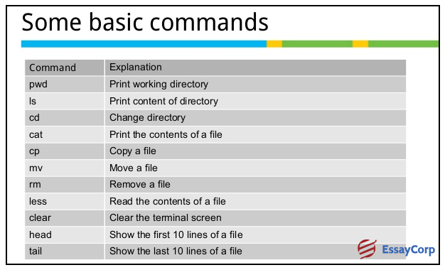

Raspberry Pi File Directories

